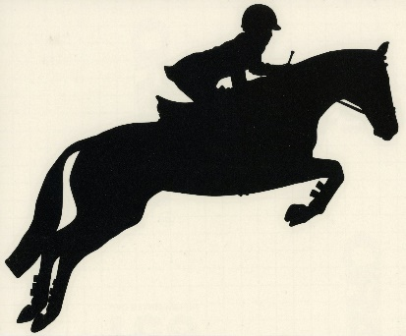
Bedlington Lane Farm, Bedlington, Northumberland, NE22 6AA
Tel: 01670 823042 07719 645283
Website: www.lanefarmequestrian.co.uk
Email: info@lanefarmequestrian.co.uk
Grand Slam Sunday Unaffiliated Show Jumping
SUNDAY 11th SEPT
Incorporating British Showjumping Club Qualifiers and Lane Farm’s Grand Slam League’s

NOW INCLUDES - The Swan 70cms Horse Class
Sponsored by The Swan, Choppington

ENTRIES ON THE DAY
PRIZES AND ROSETTES TO ALL CLASSES
CORRECT DRESS CODE APPLIES (Jackets & Ties)
REFRESHMENTS AVAILABLE

9am - CLEAR ROUND - £5.00
First class to commence 9.30 am

CLASS 1 * 50cms OPEN (Lead reins welcome)
Unaffiliated class, horses and ponies mixed. If you go clear, stay in the arena and do your jump off straight away. COURSE STAYS THE SAME AS CLEAR ROUND
Rosettes to 6th place. Prizes in kind, dependent on entries ENTRY: £8.00

CLASS 2 * 60cms OPEN
Unaffiliated class, horses and ponies mixed. If you go clear, stay in the arena and do your jump off straight away. COURSE STAYS THE SAME AS CLASS 1
Rosettes to 6th place. Prizes in kind, dependent on entries ENTRY: £8.00

CLASS 3 60cms Pairs Relay (available upon request)
Unaffiliated Class, horses and ponies mixed
Rosettes to 4th Pair. Prizes in kind (depending on entries)
ENTRY £10 per pair

*A Grandslam Achievement Cup for the most improved rider and pony (12 years and under), at these
heights; will be awarded at the end of the Grandslam Year

ANYONE CAN JUMP THE FOLLOWING CLASSES THEY ARE UNAFFILIATED/OPEN CLASSES
Please note additional information:
Anyone entering Lane Farms’ Grandslam classes, i.e. classes no’s 5 and 9, will gain points for placings in Lane Farms Grandslam Sunday Championship League if placed.
Any British Showjumping Club member will gain points for placings in these classes for the British Showjumping’s Club Leagues – Northern.
Please refer to the back page of our schedule for more information regarding the British Showjumping Club Championships, Lane Farms Grandslam Sunday Showjumping Championships.

Please note: CLASSES 3 - 11– THE COURSE WILL CHANGE AFTER EVERY CLASS and there will be a second round jump off against the clock (drawn order).

CLASS 4 70cms PONY OPEN
Incorporating British Showjumping Club
For Ponies not exceeding 148cms. Table A7. ie: All clear rounds go forward to second round over a shortened course, against the clock. 2 minute time limit in round one.
Rosettes to 6th place. Prizes cash/in kind, dependent on entries ENTRY: £10.00

CLASS 5 80cms PONY OPEN

Incorporating British Showjumping Club & *Grand Slam*
For Ponies not exceeding 148cms. Table A7. ie: All clear rounds go forward to second round over a shortened course, against the clock. 2 minute time limit in round one. Rosettes to 6th place. Prizes cash/in kind, dependent on entries - Plus points for placing’s in our LFE Grand Slam 80cm Pony league!
ENTRY: £10.00

CLASS 6 90cms PONY OPEN
Incorporating British Showjumping Club
For Ponies not exceeding 148cms. Table A7. ie: All clear rounds go forward to second round over a shortened course, against the clock. 2 minute time limit in round one.
Rosettes to 6th place. Prizes cash/in kind, dependent on entries.
ENTRY: £10.00
CLASS 7 1m PONY OPEN
Incorporating British Showjumping Club
For Ponies not exceeding 148cms. Table A7. ie: All clear rounds go forward to second round over a shortened course, against the clock. 2 minute time limit in round one.
Rosettes to 6th place. Prizes cash/in kind, dependent on entries
ENTRY: £10.00

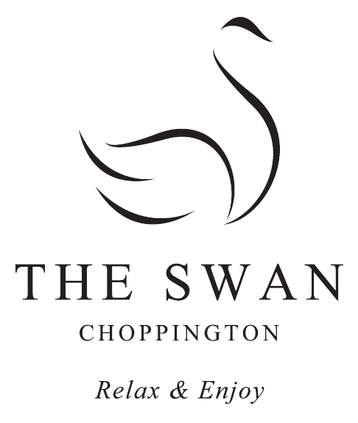
HORSE CLASSES NOT BEFORE 1.30PM

CLASS 8 Oh Go On ... The Swan … The Best In Town!

The Swan 70cms HORSE OPEN
Incorporating British Showjumping Club
SPONSORED BY THE SWAN CHOPPINGTON
For Horses exceeding 148cms. Table A7. ie: All clear rounds go forward to second round over a shortened course, against the clock. 2 minute time limit in round one.
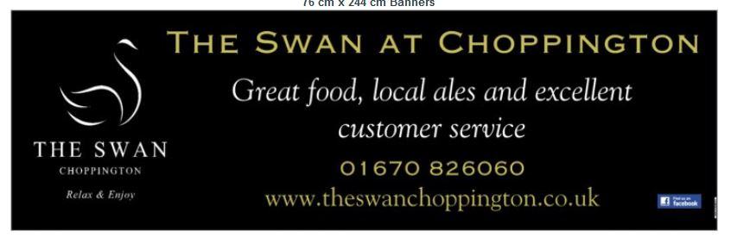
Rosettes to 6th place. Prizes 1st place – The Swan £20 Voucher, 2nd and 3rd place Lane Farm Vouchers or prize in kind, dependent on entries.
ENTRY: £10.00
CLASS 9 80cms HORSE OPEN
Incorporating British Showjumping Club & * Grand Slam*
For Horses exceeding 148cms. Table A7. ie: All clear rounds go forward to second round over a shortened course, against the clock. 2 minute time limit in round one.
Rosettes to 6th place. Prizes cash/in kind, dependent on entries
Plus points for placing’s in our LFE Grand Slam 80cm Horse League! ENTRY: £10.00

CLASS 10 90cms HORSE OPEN
Incorporating British Showjumping Club
For Horses exceeding 148cms. Table A7. ie: All clear rounds go forward to second round over a shortened course, against the clock. 2 minute time limit in round one.
Rosettes to 6th place. Prizes cash/in kind, dependent on entries. ENTRY: £10.00

CLASS 11 1m HORSE OPEN
Incorporating British Showjumping Club
For Horses exceeding 148cms. Table A7. ie: All clear rounds go forward to second round over a shortened course, against the clock. 2 minute time limit in round one.
Rosettes to 6th place. Prizes cash/in kind, dependent on entries
ENTRY: £10.00

CLASS 12 1m 05 OPEN (if requested)
Unaffiliated class. Mixed horses and ponies. If you go clear, stay in the arena and do your jump off straight away.
Rosettes to 6th place. Prizes cash/in kind, dependent on entries

ENTRY: £10.00

NOTES FOR YOUR DIARY: FUTURE DATES FOR GRANDSLAM SHOWS 2016, Inc. BS CLUB
24th September – Jump for Melanie’s Mission Fundraising Fun Show Jumping
9th October – GrandSlam Sunday Show Jumping.

ALL ENTRIES MUST AGREE TO ABIDE BY THE CONDITIONS OF ENTRY OVERLEAF AND DISPLAYED IN JUDGES OFFICE

Grandslam Sunday Championship
Lane Farm’s Sunday Championship points accumulator, leagues to run from May 2016 to April 30th 2017.
Will run as a league, gaining points for the Grandslam Sunday Championships
Points as follows: 1st 12, 2nd 10, 3rd 8, 4th 5, 5th 4, 6th 3
80 cm Open Pony and 80cm Open Horse.

Championship Cup, Sash and Prizes will be awarded to our Winners
CUP FOR THE MOST IMPROVED 50cm/60cm Grand slammer in the current Year
CUPS for the best placed LANE FARM LIVERY COMPETITOR in each league.
GRAND SLAM LEAGUE TABLES can be viewed on our Lane Farm Equestrian website: www.lanefarmequestrian.co.uk, refer to the web page – ‘Showjumping Leagues’

RULES FOR BRITISH SHOWJUMPING CLUB CLASSES
There are 8 British Showjumping Club Classes. Please note unaffiliated riders can enter these classes and win prizes and rosettes too.

The only difference being; Riders who have affiliated with British Showjumping as a Club member will receive points for the B.S Northern Regional Club League. Registered Riders and Horses/Ponies at National level are allowed to compete in Club classes and receive prizes but no points are allocated towards the Northern Club League. Adults are eligible to ride ponies.
‘Club’ members with placings in BS Club Classes, will collect points which will enable them to progress in the rankings of the BS Northern league.
Join British Showjumping ‘Club membership within seven days of being placed at Lane Farm and you will have the opportunity of winning a National Club Championship at the British Showjumping Club
League Championships; at the British Showjumping National Championships, held at the prestigious National Agricultural & Exhibition Centre, Stoneleigh Park, Warwickshire.

If you are interested in affiliating as a Club member, please refer to the British Showjumping Website for more details. … Your name will appear in the BS Club Leagues on the official BS website. You will also be presented with your Championship prize at the National Showjumpers Ball, at the NEC Birmingham, on the eve of The Horse of Show. Wow!!
http://www.britishshowjumping.co.uk/membership/club-membership/Club-Membership

Club Class Faults
Knock down-4 faults, First refusal -4 faults, Second refusal (anywhere on the course)-8 faults,
Third refusal (anywhere on the course)-Elimination, Fall (anywhere on the course)-Elimination. All other faults as per British Showjumping rule book.

League points awarded as follows: 1st-12 points, 2nd-10 points, 3rd-8 points, 4th-6 points, 5th-4points, 6th -3 points. Three points will be allocated to all those who achieve Double clears, those who are placed will receive an additional 3 points if they have jumped double clear.

PRIZES: Up to five starters – 1st Prize, Up to 10 starters – 1st and 2nd Prizes, Up to 15 starters – 1st, 2nd & 3rd prizes, Up to 20 starters – 1st, 2nd, 3rd and 4th prizes, Up to 25 starters – 1st, 2nd, 3rd, 4th and 5th prizes, Up to 30 starters – 1st, 2nd, 3rd, 4th, 5th and 6th prizes

PRIZES -
1st Prize = £15.00 Cash
2nd Prize = £10.00 Voucher for Club Class
3rd Prize = £8.00 Voucher for Sh. Stars Showjumping Class
4th Prize = Prize in kind, 5th Prize = Prize in kind, 6th Prize = Prize in kind
On occasion 1st to 3rd placings will be substituted for prizes in kind (for a change)

The Swan 70cm Horse Open - Sponsored by The Swan, Choppington
1st Prize = £20 Voucher for The Swan Choppington
2nd Prize = £10.00 Voucher for Club Class
3rd Prize = Prize in kind, 5th Prize = Prize in kind, 6th Prize = Prize in kind
On occasion 1st to 3rd placings will be substituted for prizes in kind (for a change)

CONDITIONS OF ENTRY:

- Lane Farm Equestrian do not accept liability for any loss, damage, injury or death to any person, animal, or property whilst attending Lane Farm.

- Hats approved to current standard must be worn and fastened. Body protectors are strongly advised

- Riders ride at their own risk

- LFE reserve the right to eliminate any competitor wearing inappropriate riding wear or using unsafe or incorrect tack. The Judge’s decision is final.

- LFE reserve the right to combine, split or cancel any classes as they see fit.

- Abusive behaviour of any kind and out of control riders, will not be tolerated and persons will be asked to leave without refund.

- Horses/ponies must be 4 years and over.

- Horses/ponies deemed not sound, or in an unfit state to compete, or being unfairly treated, owners/riders will be disqualified from all classes and asked to leave without refund.

- No stallions without prior permission.

- No dogs please.

- Horses not to be left tied up outside wagons/trailers.

- No mucking out on to yard and all rubbish to be removed.

- Any objections must be lodged in writing and given to the secretary within 20 minutes of an incident accompanied by a £20.00 deposit to be returned if the objection is up

- BRITISH SHOWJUMPING CLASSES: Prizes may be withheld in accordance with rule 76.6.

- Must complete appropriate entry form.

