

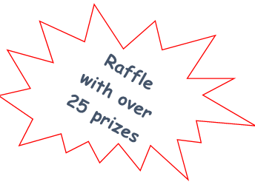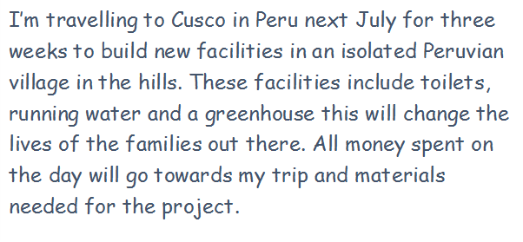

**Cake Sale**

**Prizes for 1st place**

**9am till 10am**- Clear Round

£4-Fences not to exceed 65cm

**Start 10am:**

Class 1- 55cm

Sponsored by- Paddock Hall Equestrian

£8 entry- rosettes to sixth place. Horses and ponies placed separately.

Class 2-65cm

Sponsored by- Morpeth Motor parts

£8 entry-rosettes to sixth place. Horses and ponies placed separately.

Class 3-75cm

Sponsored by- The Horse Resource

£8 entry-rosettes to sixth place. Horses and ponies placed separately.

Class 4- 75cm Relay

Sponsored by- Lane Farm Equestrian Centre

Pairs jump single course one after the other against the clock

Class 5-85cm

Sponsored by- Heaton Glass and Glaziers

£8 entry-rosettes to sixth place. Horses and ponies placed separately.

Class 6-95cm

Sponsored by- JS Services

£8 entry-rosettes to sixth place. Horses and ponies placed separately.

Class 7-1.05m

Sponsored by- Ray Carpenter- independent financial advisor

£8 entry-rosettes to sixth place. Horses and ponies placed separately.